278 Exhibit Electronic harassment from Advanced Electronics supply

https://organised-crime-of-covert-electronic-assault-nz.com/wp-content/uploads/2019/09/james_wolbert_protection_against_electronic_harassment_court_order_document_december_20082.pdf


  Home | Info | About Us | FAQ | Contact Us | E-mail
  Electronic Harassment
  Advanced Electronic Security Co. performs Electronic Sweeping and Surveys, using the best possible Technical Surveillance Counter Measures (TSCM), to determine if you're being electronically harassed. We then recommend the proper course of action to eliminate the electronic harassment threat.
  What is Electronic Harassment?
  If someone uses any electronic device to aid them in invading your person or property for the purpose of gathering information illegally, or for the purpose of causing harm, this is Electronic Harassment.
  Electronic Harassment comes in many forms and types. We'll try to explain what they are and what to do about them below.
  - Electronic Surveillance
  Electronic Surveillance is the imposed observation of a person's belongings, person or surroundings through the use of electronic listening devices, video recording or transmitting devices, spectral imaging through heat or infrared, sound or other radiation sources, and any other means of observing a person's actions, possessions or routines. Not all forms of surveillance use electronic devices and not all forms of surveillance are illegal or considered harassment. Simply observing someone using ones eyes is certainly also considered surveillance and is not illegal in and of itself. Surveillance has become quite advanced and will become more pervasive as our society progresses in technology. Micro recorders, covert hidden video cameras (such as pinhole cameras), ultra tiny microphones, micro transmitters, and other bugging devices are easy to get by anyone at spy novelty shops and online stores. For more on this subject, see Eavesdropping Threats for covert hidden camera pictures with additional information, and Electronic Surveillance page.
  - Electronic Sabotage/Interference (Jamming)
  Electronic sabotage or interference is any sabotage that is intentionally configuring personal property to either be destroyed or malfunction. Any intentional interference such as electronic noise generators, sound generators, light generators, spark gap disrupters, or any other form of EMI (electromagnetic interference) which either destroys, disrupts, causes malfunction or loss of resources is deemed to be electronic harassment.
  - Directed Harmful High Energy Devices
  This is the most dangerous form of electronic harassment and is quite easy to implement against a person. Directed harmful high energy microwave devices and weapons can include such devices and equipment that are easily available almost anywhere in the World where there are people. Microwave ovens can be modified to focus and direct up to 1200 watts or more, depending on the model, of microwave energy at a person or property and are easy to produce. The results of an attack by a high energy device can be lethal, they can kill or at the least disable a human being or other animals. Attacks from high energy microwave weapons leave blisters, cause internal bruising and/or bleeding, stimulate cancer, cause cataracts, encourage tumors to grow, generate boils, or leave red patches on the skin. Directed Harmful High Energy Weapons will have effective ranges from the point of contact to several hundred yards. Directed Harmful High Energy Weapons can be used to destroy electronic devices and cause severe interference in computers and alarm systems which can allow forced entry or destruction of vital data. Radar guns are available from surplus stores most anywhere and can be obtained from ex-military sources or even police departments. Radar gun power outputs range from a two or three watts to 3 Megawatts! Portable radar guns range in size from small hand held devices to vehicle mounted long range high power models. These devices have very long ranges due to their greater power, higher frequencies and shorter wavelength. Radar guns emit long or short pulses of high energy capable of causing instant damage or death to living creatures. Semiconductor destruction or malfunction, brain damage & stopping vehicles are other uses for these devices. Other forms of directed harmful high energy include devices such as tasers, klystron guns (radar guns), ion beam guns, plasma pulse guns, soliton bombs, and many more devices.
  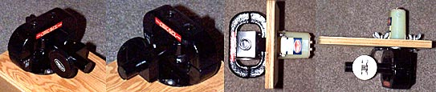
  Directional Microwave EMP Rifle (PARTIAL KIT) Partial kit (shown above). This partial kit will include a 50,000W (yes it says 50KW) Watt X-band military microwave magnetron with complete spec sheets from two manufacturers and operational information to make it work (about 30 pages), EMP rifle plans (over 49 pages), and qty:3 (12KV @ 1A) rectifiers. A device such as this can be made the size of a super soaker water gun, it operates at 9.2GHz and with a properly tuned horn antenna will have an effective range of over 300 yards (possibly more with larger antenna). Such a device could possibly cause semiconductors to burn out, microprocessors to malfunction, inductors to counter induce and create CEMF, induce RF noise, cause ionization of air or gases, cause junction rectification and erase computer data on hard drives, disk and solid state device. Operating such a device may be in violation of State or Federal Laws, consult your Local authority before operating such a device. UPS GROUND SHIPPING ONLY DUE TO INTENSE MAGNETIC FIELD FROM MAGNETRON. Do not purchase this kit if it is illegal to own or operate in your area. (This kit is real and available on the internet. The above photo and description was taken directly from an internet website, but we will not tell you where to find it!)
  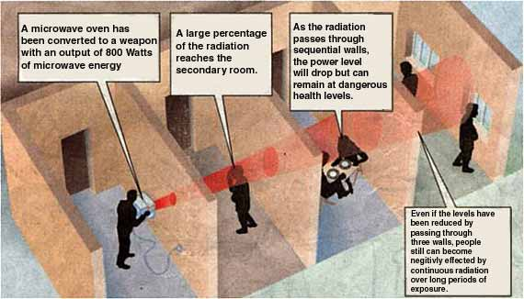
  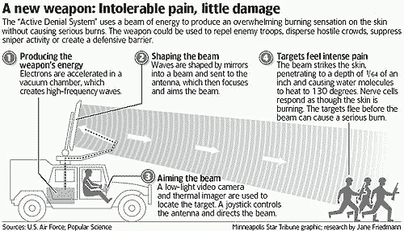
  Directed energy weapon for "Active Denial" is now being deployed by the military.
  - Voice/Data/Image induction
  This form of electronic harassment causes an individual to think they are loosing their mind or that they have a mental illness. There are 3 known methods of imposing VDI induction.
  - Microwave Carrier ULF-UHF Induction Method. This method utilizes a modulated microwave signal with either an audio, video, or other form of signal or even data may be used. The microwave energy with the VDI (Voice/Data/Image) carrier signal is then directed to the target area or individual. The reaction to this modulated microwave energy from one individual to another will usually be slightly different making it very difficult to diagnose as electronic harassment. The Voice/Data/Image induction form of harassment causes victims to hear voices in their heads or see random images or lights. Similar technology was developed to enable communication between humans and dolphins or even was purported to be used by secret agencies for the purposes of mind reading and control. A device known as the wireless neurophone has been patented along with other such devices that perform similar functions. A microwave carrier ULF-UHF induction device can be placed at a targets location and operated and monitored remotely. Transmission locations can be concealed in the same ways that cell telephone transmission sites so that they cannot be identified easily. See Stealth for some examples of the way cell antennas can be hidden in plain sight.
  - Direct Contact Induction Method. This method requires direct skin contact of the subject. Voice/Data/Image induction (VDI) is induced through the skin, using the natural ability of the skin to conduct energy. The DCI method uses a simple high voltage D.C. carrier, which is modulated with the VDI signal and is coupled to the subject body using capacitive skin pads. The contacts need to contact any part of the skin anywhere on the body. The signal is received and interpreted by the nerves below the skin surface and sent to the brain which processes the information signals, causing the images or sounds or data to appear to the target without the actual use of their eyes or ears. A similar device is also known as the neurophone. There are many patents for similar devices. Evidence of unauthorized use on someone is two or more circular red marks on the skin or two or more blisters.
  - Magnetic Pulse Induction Method. The neurons within the nerves and human brain are very sensitive to magnetic fields. The MPI method uses an induction coil to induce a low to medium magnetic field in and around the brain causing the neurons to misroute, slow down or revert. This form of electronic VDI harassment is often diagnosed as EMI (electromagnetic interference) sensitivity, which is similar to someone getting headaches from prolonged usage of cellular phones or nausea from being around power lines for extended periods of time. Magnetic Pulse Induction Method may be employed by using a device implanted within the targets home or surroundings and can be operated remotely.
  - Radiation
  Radiation is a very common form of harassment. A potential harasser can easily buy an old x-ray gun from a surplus dealer and with only slight modifications use it to bombard a target with deadly amounts of x-ray radiation. Radiation devices can be battery powered and used for long periods of time. High exposure to x-ray radiation will cause tumors, brain disorders, mental illness, tremors, headaches, cataracts, seizures or even death. Radiation harassment is usually done over long periods of time, ranging from days to years, in order to induce harm. Radiation harassers can also get various radioactive materials such as thorium nitrate, plutonium oxide, uranium nitrate, and uranyl nitrite. Using radioactive materials a harasser can cause a terrible and agonizing death.
  - Implants
  Implants are without a doubt the most invasive form of harassment. Electronic implants consist of transmitters, ESF generators, micro-neurophonic transceivers, tracking devices and other micro sized devices designed to cause harassment by tracking or controlling movement and thought. The most common implant was designed many years ago and is still used to this day. It consists of a unit that is powered by bodily fluids and is capable of transmitting voice signals, high voltage pulses, emitting a small tracking beacon signal, or other unspecified uses (mind control).
  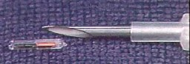 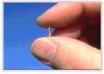
  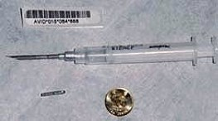 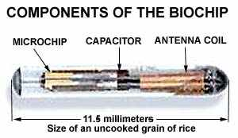
  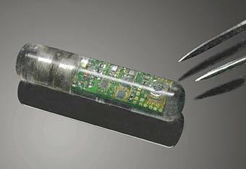 |  | Newest version of a biochip implant. For more information about this chip go to  http://www.nasatech.com/Briefs//May99/ARC14280.html
  - Millions may be carrying microchips in their bodies worldwide. The Safe Medical Devices Act, which became a law in 1990, requires USA manufacturers of implants and medical devices, to adopt a method for identifying and tracking their products permanently implanted in humans, and to keep track of the recipients, in case malfunctions arise. Breast implants, pacemakers, replacement heart valves and prosthetic devices implanted in millions worldwide are all to be tracked. And one of the methods used to track these devices is implanting microchips which store data about the manufacturer, the surgeon, the date of implant, etc.
  - Laser Harassment Devices
  The use of simple, easy to procure lasers to harass or "Dazzle" a subject is becoming more prevalent. Subjects of this type of harassment have reported seeing "little red dots" on their curtains, through their windows or on themselves. There have been numerous reports of people being momentarily blinded by red lights (red lasers) while they were driving in their cars. Some of these incidents have resulted in traffic accidents, although no permanent blindness has yet to be reported as a result of being "spotted".
  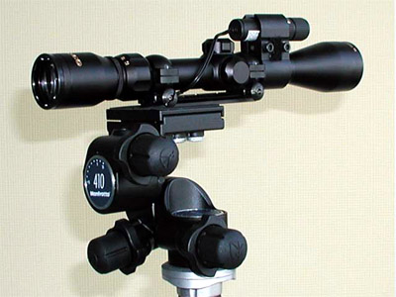
  Laser gun sight, zoom rifle scope, 3-axis adjustable tripod head
  The parts that make this device can be purchased at any gun store
  and the tripod is a standard issue camera tripod.
  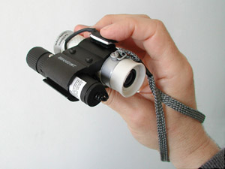
  Hand-held unit with laser gun sight and golf scope
  United States Patent 5,629,678
  Gargano , et al. May 13, 1997
  Personal tracking and recovery system
  Abstract
  Apparatus for tracking and recovering humans utilizes an implantable transceiver incorporating a power supply and actuation system allowing the unit to remain implanted and functional for years without maintenance. The implanted transmitter may be remotely actuated, or actuated by the implantee. Power for the remote-activated receiver is generated electromechanically through the movement of body muscle. The device is small enough to be implanted in a child, facilitating use as a safeguard against kidnapping, and has a transmission range which also makes it suitable for wilderness sporting activities. A novel biological monitoring feature allows the device to be used to facilitate prompt medical dispatch in the event of heart attack or similar medical emergency. A novel sensation-feedback feature allows the implantee to control and actuate the device with certainty.
  Read The Complete Patent Information
  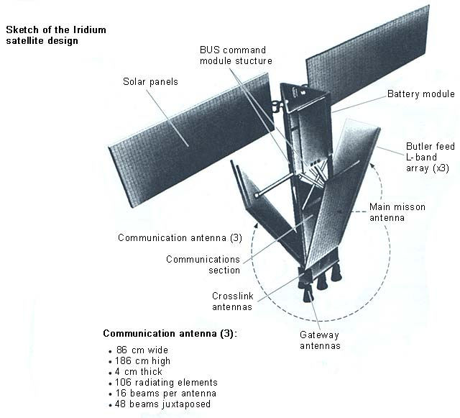
  This is one of 66 low-earth orbiting (LEO) satellites comprising the Iridium satellite system. The original company went bankrupt so the US Department of Defense assisted in making sure the system stayed in operation. The system is currently maintained by the Boeing Company.
  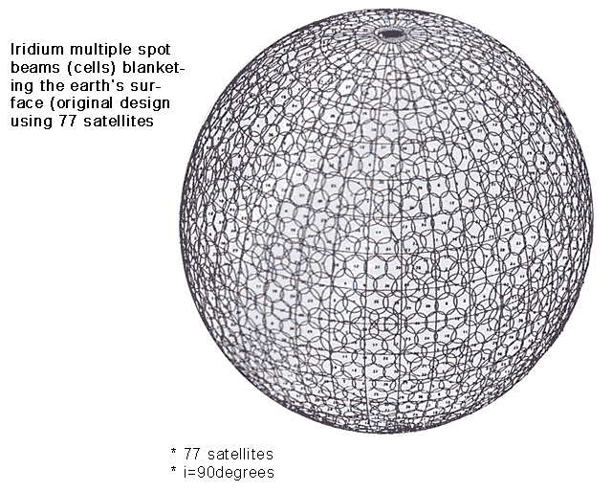
  This is a diagram of the planetary coverage of the Iridium system. This system has transmit and receive coverage of the entire planet. Each circle is a coverage sector.
  Of course there are many other forms of electronic harassment not mentioned here, but the most common forms of electronic harassment that you may likely encounter have been covered. Please read Microwave Detection - Remote Mind Control Technology for more on this subject.
  Symptoms of Electronic Radiation Exposure
  Symptoms may include but are not limited to: Headache, eye irritation, dizziness, nausea, skin rash, facial swelling, weakness, fatigue, pain in joints and/or muscles, buzzing/ringing in ears, skin numbness, abdominal pressure and pain, breathing difficulty, irregular heartbeat, sexual stimulation and hearing voices (see Patent #4,858,612). Additional symptoms have been reported in some individuals such as paralysis, balance problems, body and/or muscle spasms, convulsions, confusion,depression, difficulty in concentrating, seizure, sleep disturbances, and memory difficulties.
  What Can Be Done To Protect Against Electronic Harassment?
  In a legal sense, there isn't too much that can be done. You could change your venue, relocate or move to avoid the harasser but this isn't usually a practical method for a variety of reasons.
  For starters, the best thing to do is give us a call from a secure phone. We will conduct a sweep of the suspect areas to locate the source of the suspected harassment and then assist in a course of action to stop the harassment.
  Natural obstacles are cheap and effective in blocking most X-rays and microwave or RF (could be a radar gun) signals that a harasser might use. Mountains, caves, desert areas, and large lakes or oceans offer excellent protection and can block or distort most forms of electronic harassment.
  Shielding signals with Passive or Active shielding can be an effective measure.
  If harassment is general to an area and not specifically directed to you, simply moving to another location is the easiest method to stop the harassment. If the harassment is specific to you, then you'll need to employ some sort of shield or cover, such as mountains or a cave. Shielding may be your only alternative to stop the harassment if you cannot employ natural obstacles or shields. Passive shielding is less expensive then Active shielding and consists of special metal materials designed to block high frequency RF energy, X-rays, etc. Active shielding uses sophisticated electronic equipment to jam, capture, redirect, distort or nullify the harmful energy.
  It isn't legal for a private individual, a company or a corporation to use electronic harassment on you. The military and law enforcement, however, can use non-lethal weapons (see USC Title 50 Chapter 32 Section 1520a).
  Further, testing of electronic equipment; discovering unauthorized electronic surveillance; training of intelligence personnel by officers the United States is allowed.
  http://www4.law.cornell.edu/uscode/50/1805.html
  Notwithstanding any other provision of this subchapter, officers, employees, or agents of the United States are authorized in the normal course of their official duties to conduct electronic surveillance not targeted against the communications of any particular person or persons, under procedures approved by the Attorney General.
  
  Advanced Electronic Security Co. is an experienced and knowledgeable professional private investigative agency with the ability to find and then help you to eliminate Electronic Harassment. Advanced Electronic Security Co. is also a specialist in electronic surveillance and counter-surveillance. We only utilize the best and latest technology and techniques to assist and support victims of Electronic Harassment.
  
  
  C2Cam show 2008-8-5 With George Noory.
  downloadable link
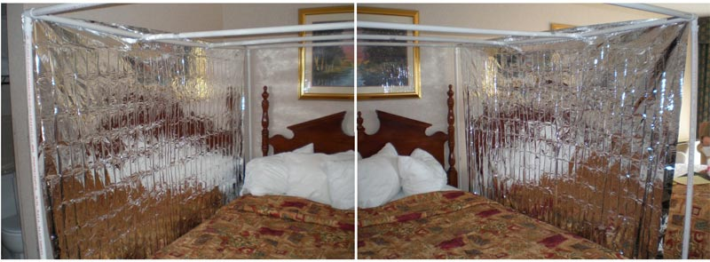
The Bugsweep's Electrostatic Active Shield System protects the targeted individual from directed energy attacks. The transmission panels emit an electrostatic energy that forms a protective field. Any directed energy attack is deflected off this energy field giving the targeted individual the ability to get on-going relief.
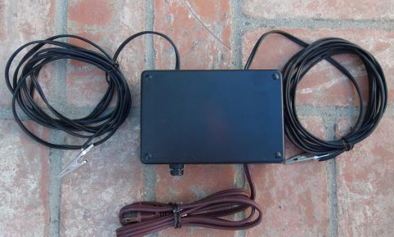
The Bugsweep's Active Shield System is powered by a custom-designed
electrostatic transmission power supply.
Call us direcct at 760-668-2245 for more information.

Return To Info Return To Home

760-668-2245  Do Not Text  Email: bugsweeps@earthlink.net  Over 30 years of specialized service  over 2,500 locations swept.  PLEASE DO NOT CONTACT US  FROM A SUSPECT TELEPHONE OR FACILITY  WHEN INQUIRING ABOUT BUG SWEEPING OR OUR  SERVICES AND SURVEYS. |   Read about us in  Business Week

