276 exhibit 14 Movies About Wrongful Convictions Streaming Now That'll Make You So Enraged
by Angelica Florio
June 22, 2018
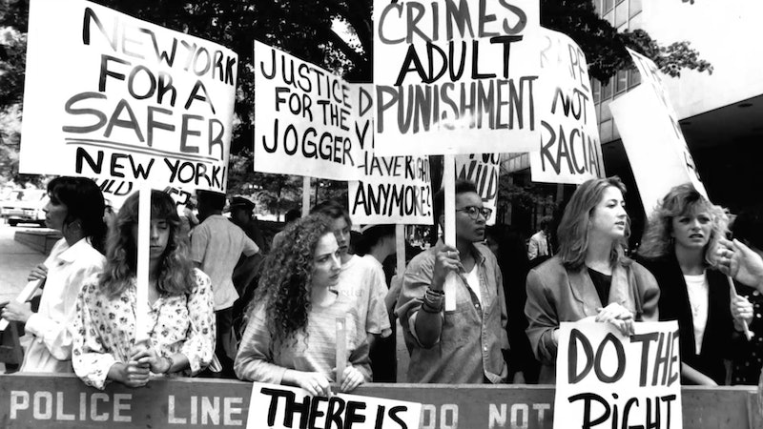
Sundance Selects
In true crime, various echelons of the genre exist. There are the stories that make you disgusted by human nature and grateful for the criminal justice system. There are other cases that remain unsolved and make you muse over whodunit. And then, there are the tales of wrongful convictions that keep you up at night because you simply can't believe that a legal investigation could fail so drastically. These 14 movies about wrongful convictions will make you enraged, and wanting to fight for justice more than ever.
Most of the time, wrongful conviction stories leave you with mixed feelings. Often when a wrongful conviction comes to light, you're hearing about it because a person is being exonerated for the crime which put them in jail. As exciting as it is that that person is finally receiving justice, it's infuriating that they were sent away for an act they didn't do. It's a shameful facet of the American justice system, and if you're looking for more information on how that all actually happens, each of these movies are worth a watch. These films explore what goes wrong with the criminal justice system, from racial biases to forced/false confessions, and will leave you angry and ready to take action.

1

'The Central Park Five'
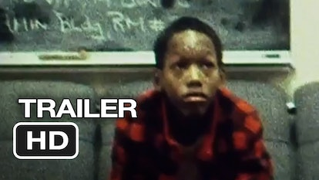
PBS/YouTube
While you patiently await Ava Duvernay's upcoming Netflix series about this horrendous story, you can check out Ken Burns' documentary. It tells the true story of five innocent black men wrongly convicted of raping and murdering a white woman. The movie is available for streaming on Amazon Prime.

2

'Conviction'
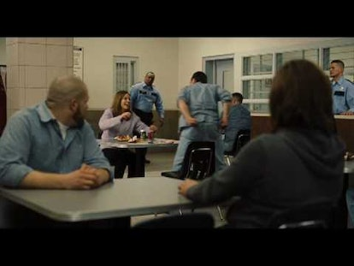
FoxSearchlight on YouTube
Hilary Swank and Sam Rockwell star in this fictional film about a woman who attempts to prove her convicted brother's innocence. You can rent it for $3.99 on iTunes or Amazon.

3

'After Innocence'
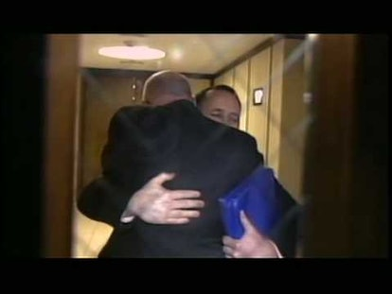
AltinaFilms on YouTube
As disheartening it is to know that wrongful convictions happen so often, this documentary about people finally receiving the justice they deserve is at least a little bit heartening. Check it out on Netflix.

4

'The Green Mile'

Warner Bros./YouTube
Based on a Stephen King novel, this movie follows a death-row officer who meets a prisoner named John (Michael Clarke Duncan) who, under supernatural circumstances, reveals that he has been wrongfully convicted. It's a classic movie, and you can stream it on Hulu.

5

'The Confession Tapes'
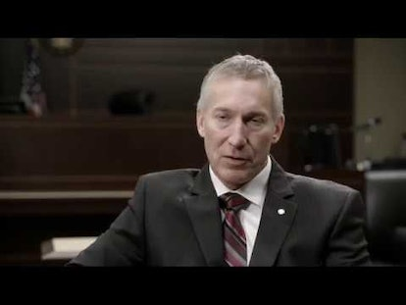
Netflix/YouTube
This seven-part Netflix series investigates six different cases of people who confessed to crimes that they did not, in fact, commit.

6

'The Shawshank Redemption'

Columbia Pictures/YouTube
While this 1994 film suggests that its protagonist, Andy Dufresne, was actually innocent for the crime that put him in jail, some people believe that Andy was a master-manipulator who actually was guilty. The dubiousness of innocence vs. guilt is part of its greatness, though. You can rent it on Amazon or iTunes for $3.99.

7

'Paradise Lost: The Child Murders At Robin Hood Hills'
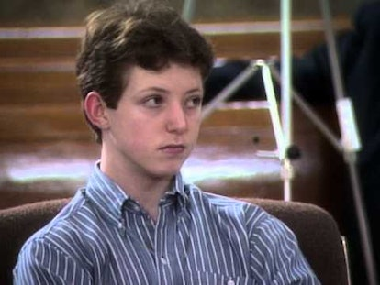
HBO/YouTube
The story of a group of kids wrongly convicted for a murder unfolds over three parts in these documentaries, available on HBO Go and Amazon Prime.

8

'The Thin Blue Line'
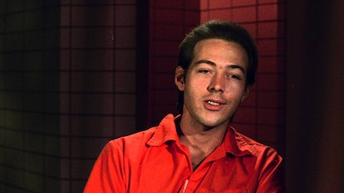
IFCFilmsVOD on YouTube
A 1976 murder of a police officer is the subject of this documentary, which reveals a great deal of corruption within the criminal justice system. It's available on Netflix and Hulu for streaming.

9

'In The Name Of The Father'
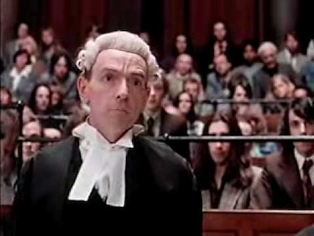
Universal Pictures/YouTube
This film is based on an autobiography called Proved Innocent: The Story of Gerry Conlon of the Guildford Four. It stars Daniel Day-Lewis and Emma Thompson, and you can rent it on Amazon or iTunes.

10

'An Unreal Dream: The Michael Morton Story'
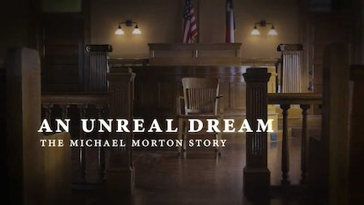
First Run Features/YouTube
After spending 25 in prison, convicted of murdering his wife, Michael Morton was proved innocent. The hard-to-believe story unfolds in a documentary that's available on Amazon Prime.

11

'Amanda Knox'
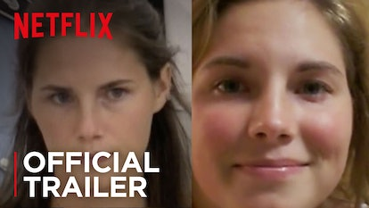
Netflix on YouTube
One of the most notorious wrongful conviction cases in recent history is that of Amanda Knox, and this Netflix documentary tells the full story. It's as frustrating as you'd expect.

12

'Double Jeopardy'

Paramount Pictures/YouTube
In this fictional story, Ashley Judd plays a woman who must track down her husband, who framed her as a murderer. It's an exciting thriller, and you can rent it on Amazon or iTunes.

13

'A Murder In The Park'
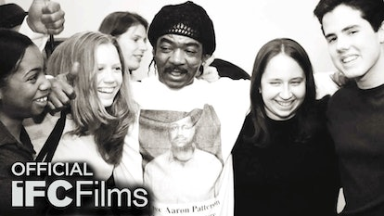
IFC Films on YouTube
An anti-death penalty activist successfully exonerated a man who had been convicted of murder, and this documentary tells the story behind how that happened. It even questions the legitimacy of the exoneration. You can find it on Netflix.

14

'The Fugitive'
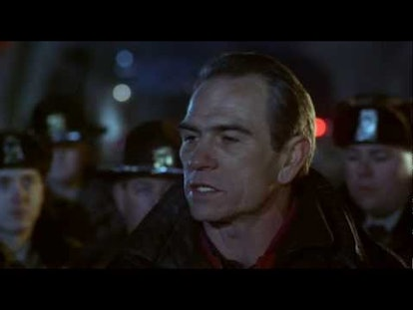
Warner Bros./YouTube
This Harrison Ford movie tells the story of a man who must prove his innocence of a crime he was wrongly convicted of committing. As you can tell from the film's name, he's on the run from the police, and it's a race-for-your life story that you can't forget. You can watch it with a Cinemax subscription or rent it on Amazon and iTunes.
Your blood might boil while you watch all of these movies, whether they're fact or fiction. It's totally worth it, though, for the thrilling look at how things aren't as black and white as you might have originally thought.
More like this


The Real-Life Robbery Behind 'The Gold' Is A Truly Shocking Tale
By Bustle UK


Blake Lively & Ryan Reynolds' Relationship Timeline Now Includes 4 Babies
By Jake Viswanath


A New 'Guardians Of The Galaxy Vol. 3' Trailer Teases The Film's Hot Soundtrack
By Alyssa Lapid


How to Stream 'Magic Mike’s Last Dance'
By Princess Gabbara

Get Even More From Bustle — Sign Up For The Newsletter
From hair trends to relationship advice, our daily newsletter has everything you need to sound like a person who’s on TikTok, even if you aren’t.

Bustle Daily
Up Next
Submit
By subscribing to this BDG newsletter, you agree to our Terms of Serviceand Privacy Policy

TV & Movies

Kate Hudson Almost Played The Lead In This Iconic ’00s Film
“I was bummed out… I really wanted that part.”
by Darshita Goyal
Feb. 15, 2023

Getty Images/JC Olivera/Stringer
The year is 2001 and Baz Luhrmann’s Moulin Rouge! has just hit cinema screens, paving its way to becoming the cultural phenomenon it is today. The camera zooms in on Satine, the protagonist who is singing the iconic song, “Diamonds Are A Girl’s Best Friend.” Everything is as it should be but instead of Nicole Kidman, we see Kate Hudson descending from the swing in that sultry embellished bodysuit. A rather exciting possibility, right? Well, as it turns out, this was almost a reality.
Whilst in conversation with Erin and Sara Foster of The World’s First Podcast on Feb. 9, the Glass Onion actor revealed that she actually auditioned for the role of Satine before Kidman was confirmed as the lead. The hosts asked Hudson about any role that she’s missed out on so far in her career and she responded, “It was Baz Luhrmann. It was Moulin Rouge!. I really wanted that part and it was written at the time for a 19-year-old girl, I believe.”
The 43-year-old actor explained that Kidman had a friendship with the director that couldn’t be contended with. “Then what happened was I was sort of in the auditioning process and then Nicole had a relationship with Baz and wanted to do it,” she said. “And so of course, it was like, 'Nicole Kidman's doing it.” Hudson also sung praises of Luhrmann, explaining that the audition process was very hardcore and she “just fell so in love” with him after that one meeting.
“Working with [Luhrmann] is so wonderful, he's so wonderful. And energetically, I just felt very connected to the way he does things. So I was bummed out. Of course, [I] totally got it, because it's Nicole,” she recalled. Moulin Rouge! opened to great success and earned Kidman her first Oscar nomination as well.
In the interview, Hudson also revealed that she auditioned for the part of Jenny Everdane — that eventually went to Cameron Diaz — in Martin Scorsese's Gangs Of New York. However, despite the passing disappointment, the actor reminds herself not to look back at the past with regret. “You know that thing where it's like 'oh, one decision could change the trajectory of your life?' I don't ever want to think of that way,” she added.
One of Hudson’s biggest hits, How To Lose A Guy In 10 Days celebrated its 20-year anniversary last month. And to mark the occasion, the actor went live and did a fun Q&A on her Instagram with costar and friend Matthew McConaughey.
SEARCHCLOSE

Entertainment
Style
Wellness
Life
Rule Breakers
Originals
Amplifying Our Voices
Shop
Video
Beautopia

Choose an edition:
https://www.psychologicalscience.org/observer/convicted-memory
US/UK
NEWSLETTERABOUTARCHIVEDMCAADVERTISETERMSPRIVACYMASTHEADEDITORIAL STANDARDSYOUR PRIVACY OPTIONS
© 2023 BDG Media, Inc. All rights reserved.
- News
- Research Topics
- Conventions & Events

- Journals

- Observer Magazine

- Funding & Policy

- Members

- Employment
- Podcasts
- About



Top of Form
Bottom of Form

- LOGIN

- JOIN APS
Observer > 2021 > September/October > Convicted by Memory, Exonerated by Science

FEATURED

Convicted by Memory, Exonerated by Science
Michael P. Toglia, Garrett L. Berman
August 30, 2021
TAGS:
- CRIMINAL JUSTICE
- FALSE MEMORY
- FEATURE
- MEMORY
- RACISM

Log in to Save for Later

Download PDF


The criminal justice system was designed to find and punish actual perpetrators guilty of the crimes of which they are accused. Questions and claims of innocence were rarely examined and, until recently, were generally dismissed out of hand. However, the advent of DNA-based exonerations some 30 years ago brought to light an alarming number of wrongful convictions that have called the system’s mission and methods into question.
Nevertheless, it is difficult to establish how often innocent defendants are found guilty, a point made repeatedly in the literature (e.g., Norris et al., 2017). Based on Norris et al. (2017) and other registry projections (e.g., National Registry of Exonerations) investigating samples of DNA-based exonerations, we estimate the frequency at about 5% in the United States. But surely this is a conservative estimate, as it is extrapolated from known exonerations and excludes wrongful convictions that have not been overturned. In any event, the National Registry of Exonerations reports that nearly 2,800 wrongful convictions have been reversed since 1989 (Norris et al., 2017). Fortunately, these shockingly high numbers have served as a clarion call to actively address the serious consequences of wrongful incarceration—which include not only the punishment of innocent people but citizens’ mistrust of the system and the failure to jail real perpetrators, who may go on to commit additional violent crimes.
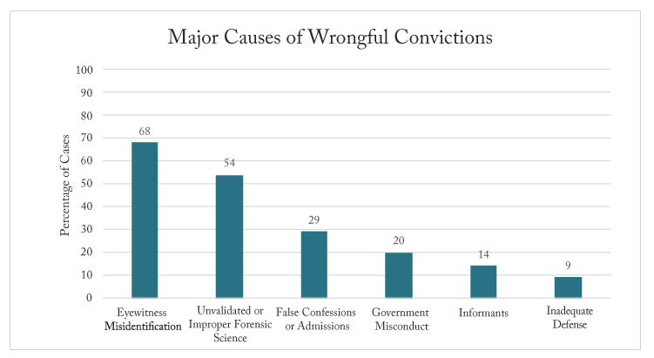As of 2018, work by the Innocence Project had led to 351 exonerations. Mistaken identification contributed to erroneous convictions in 239 (68%) of the cases. (The percentages sum to more than 100% because multiple causes contributed to many exonerees’ wrongful convictions.)
In 2016, we initiated a program of research exploring factors that contribute to wrongful convictions. Given our long-standing interest in memory and cognition, especially in the arena of eyewitness recollection and testimony, we were focused on memory factors that led juries and judges to reach guilty verdicts for defendants who later were determined to be not guilty. The basis for our research was a data set of such cases taken on by the Innocence Project, an initiative that strives to exonerate the wrongly convicted through DNA testing and criminal justice reforms. A large body of findings in the lab and the field has shown that eyewitnesses’ memory for perpetrators is subject to the same frailties and biases that typify recall of events and daily activities (Lindsay et al., 2007; Bialer et al. 2021). Although in some circumstances, mistaken identifications may be just as likely as correct identifications, lineups and showups (one-person “lineups”) are regularly used by investigators because there is no physical trace evidence in a large majority of cases (Wells, 1995; Wells & Loftus, 2003). In such cases, memory is the evidence!
Eyewitness lineup procedures at their core produce memory evidence which, as with any recollection, is subject to error and contamination. Though our research has a U.S. focus, the problem of wrongful convictions is global in scope. As an aside, we have collected international data (Toglia et al., 2018) in which we compared exonerations in the United States (N = 351), other Western countries (N = 900), and non-Western countries (N = 595) to further pinpoint factors responsible for convicting the innocent. Key results indicated that the leading cause of erroneous convictions outside of the United States was government misconduct (29%), followed by eyewitness memory issues (25%). To learn more about eyewitness identification guidelines worldwide, we recommend consulting Fitzgerald et al. (2021).
Psychological science in reforms
The impetus for reforming eyewitness-identification procedures was a seminal 1978 article by social psychologist (and APS James McKeen Cattell Fellow) Gary Wells distinguishing between estimator variables and system variables in criminal investigations. Following this classification, hundreds of laboratory studies have demonstrated the negative impact these variables may have, individually and collectively, on eyewitness memory and identification accuracy. Estimator variables are those present during a crime that could affect a witness’s accuracy (e.g., the witness’s stress level; the race of the perpetrator and the witness; and conditions that could affect the witness’s view, such as distance and lighting). They reduce the witness’s ability to encode and store the event (Wells & Olson, 2003) but are outside of the control of the legal system. Conversely, system variables (e.g., lineup instructions; selection of “fillers,” or people presented along with the suspect in lineups; and use/non-use of a blind administrator) can be controlled and modified by investigators. Using this partitioning scheme, Wells suggested new strategies for researching and reforming eyewitness-identification procedures in ways that could impede wrongful identification and, in turn, reduce the conviction of innocent individuals. His paper was an immediate game changer: In the 1980s, researchers armed with Wells’s distinction published a number of important laboratory and field studies showing that several lineup reforms (e.g., informing witnesses that suspects may or may not be in the lineup) reduced the identification of innocent suspects. Wells’s initial classification continues to have a tremendous influence on both methods and theory in the science of eyewitness lineups. More recently, it has also informed important strides in policy and reform (see Smith et al., 2021, for an in-depth review).
A large body of findings in the lab and the field has shown that eyewitnesses’ memory for perpetrators is subject to the same frailties and biases that typify recall of events and daily activities.
By the start of the 1990s, reform-oriented research by social and cognitive psychologists was growing exponentially and drawing increased attention in the criminal justice system. The timing of this growth was fortunate for the legal community. As framed by Toglia, Lampinen, and Smith (2021), “the criminal justice system found itself in a state of crisis” (p. 6) with the introduction of polymerase-chain-reaction DNA testing in 1984, followed shortly by the discovery of a disturbing number of innocent persons jailed (and, in some cases, sent to death row to await execution) for serious crimes they did not commit. These findings were a major force behind the launch of the Innocence Project in 1992 by Barry Scheck and Peter Neufeld.
Paralleling the genesis of the Innocence Project was the public’s increased awareness of miscarriages of justice, as portrayed through both news stories and TV crime dramas such as NYPD Blue and Law & Order. More recently, films such as Just Mercy and Conviction, both from 2019, and documentary series on Netflix and other streaming services (e.g., The Innocence Files, The Innocent Man) have focused on wrongful convictions involving actual events and people. These real-life stories have highlighted systemic problems within a judicial system that traditionally has focused on guilt. Only within the past decade has innocence been thrust into the public eye and national discourse.
Why the innocent are convicted
The criminal justice system treats physical evidence as items to be preserved and protected because they could be contaminated. Unfortunately, and inconsistent with psychological scientists’ recommendations, the system’s approach to the collection and preservation of memory evidence is qualitatively different (Wells & Loftus, 2003). Compared to the protection of crime scene evidence, investigators receive less formal training in the security of testimonial evidence obtained by interviewing witnesses concerning their memory for the crime and the suspect. Even though police interrogators typically have considerable experience in interviewing suspects and witnesses, they have less experience with issues regarding the vulnerability of human memory to suggestive information (see Loftus et al., 1978, for a seminal demonstration) that taints the collection of remembrances.
Given this distinction and our desire to limit contamination due to multiple causes contributing to wrongful convictions, for the purposes of this article we focused on memory errors involved in misidentification cases. Our first qualitative step, archival analyses, required homing in on mistaken-identification cases within the Innocence Project, which attributes wrongful convictions to five additional causes beyond eyewitness misidentification: unvalidated or improper forensic science, false confessions or admissions, government misconduct, informants (jailhouse prisoners who are often compromised), and inadequate defense.
Following our development of an initial coding scheme, we analyzed cases for 60 variables across five different categories (Toglia et al., 2017):
- Variables known to increase eyewitness inaccuracies during encoding (estimator variables) and at retrieval (system variables)
- Legal safeguards (e.g., expert testimony, presence of an attorney at the lineup)
- Suspect characteristics (e.g., race, juvenile status, mental disability)
- Case characteristics (e.g., conviction state, type of crime)
Determining the presence or absence of these factors is key to understanding their individual and combined roles in exoneration cases as well as the utility of recommended reforms.
We quickly realized that crucial data on these factors were missing from the Innocence Project website. Needing more data for an adequate archival study, we gained access to the Innocence Record, a database that houses documents concerning each exoneree’s conviction, including motions and transcripts from trials, such as witnesses’ testimonies and judges’ instructions.
The Innocence Record revealed 254 cases wherein the primary cause of conviction was eyewitness misidentification. We then narrowed the set to 104 cases in which mistaken identification was the sole factor for conviction—what we refer to as “pure” misidentification cases. Finally, we removed any profiles with little to no associated archival documents, reducing the final data set to 57 “pure” cases. Transcripts and other accompanying documents related to those cases provided a rich database that allowed us to use our five classification categories and expand our coding scheme to 123 variables.
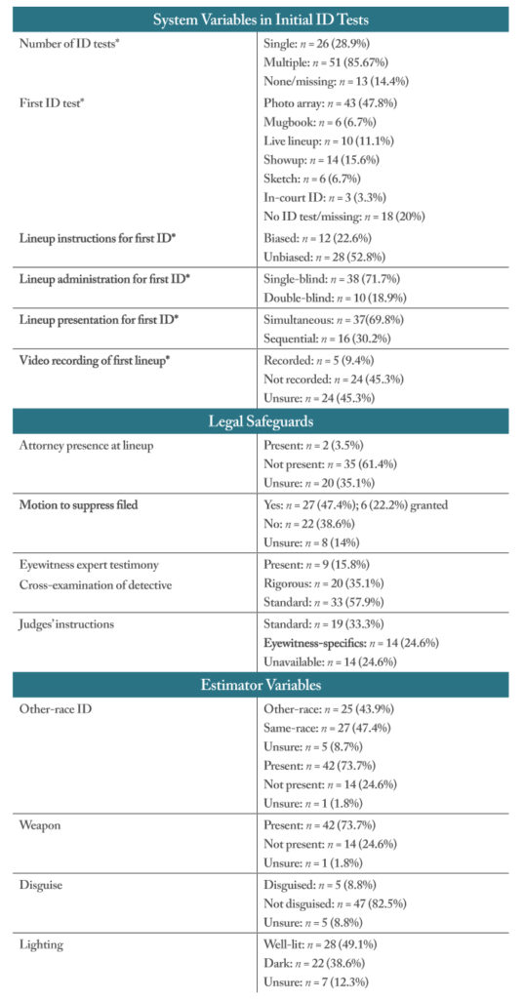The table above shows the frequency of factors related to system variables, legal safeguards, and estimator variables in an archival analysis of 57 eyewitness misidentification cases.
The table at left provides a snapshot of the findings from these 57 cases. It is notable that the majority involved innocent suspects identified in multiple selection procedures. The use of multiple identification tests varies widely by jurisdiction, but more troubling is the increased risk of false identification resulting from repeated procedures (Steblay & Dysart 2016). That pattern in initial identifications, coupled with biased pre-lineup instructions in which the witness felt compelled to choose, is concerning, especially given that attorneys were rarely present during lineup administrations.
Another item that drew our attention was the more frequent use of simultaneously administrated lineups, in which lineup members or their photos are presented collectively, compared to sequential lineups, in which each person or photo is shown individually. The latter, it’s worth noting, has resulted in fewer misidentifications in lab studies (Cutler & Penrod, 1988), a finding supported by meta-analysis (Steblay et al., 2001).
Though the debate over the superiority of sequential lineups continues (Kaesler et al., 2020; Steblay et al., 2011), theories of memory provide some perspective. One such position is fuzzy-trace theory (FTT). Advanced by Reyna and Brainerd (1995), FTT proposes that verbal and visual information is encoded in two types of independently developed memory traces. One results from processing verbatim aspects and contains exact, detailed information (e.g., a person’s specific facial and physical characteristics). The other represents the gist of the information, or general characteristics (e.g., a person’s gender, hair color, and approximate height). Both verbatim and gist representations contribute to accurate memory, but in explaining inaccuracies such as misidentifications, the focus is on gist processing. Returning to the comparison of lineup procedures, FTT predicts that simultaneous lineups provide considerable competing gist cues, obscuring differences among lineup options. Sequential lineups, by contrast, may result in more accurate identifications because they alternate a good verbatim cue (in the form of the actual perpetrator) with good gist cues, making the recollective differences more apparent.
Reliance on gist is also relevant to understanding the “own-race bias effect,” in which witnesses identify suspects of their own race better than suspects of other races. FTT argues that decreased familiarity with other races may increase interference from competing gist cues (Meissner & Brigham, 2001). In the entire Innocence Project database, 42% (375 post conviction DNA exonerations) of all cases involved cross-race misidentifications, and 44% (25) of the pure cases were cross-race mistaken identifications. Notably, each of those 25 cases involved a White witness. In 23 cases, the White witness misidentified a Black suspect; the other two misidentified suspects were Hispanic.
Referring again to the table,, the estimator variables in the bottom panel include data regarding the frequency of crimes committed with a weapon (73.7%). This raises the specter of the “weapon-focus effect,” in which witnesses to a crime involving a weapon are much more likely to misidentify a suspect (Pickel, 1999). In FTT terminology, focused attention produces strong verbatim memories of the weapon but only gist impressions of the assailant’s face.
Moving from postdiction to prediction
Though other theories could be discussed, our current purpose is not to compare explanatory positions. Rather, FTT is our preferred approach to introduce postdiction, or a “looking back” strategy, which in the present context translates to leveraging theoretical expectations about what patterns should be evident in archival searches of wrongful-conviction cases.
This novel strategy is significant in a number of ways. In particular, it can improve the ecological validity of eyewitness research. Dissenters often question the admissibility of testimony based on that research and the generalizability of the findings because the methods used to test eyewitness factors do not parallel actual eyewitness situations (Konečni & Ebbesen, 1986). The courts have traditionally agreed with this argument, excluding expert testimony on the reliability of eyewitness memory on the grounds that it is not based on sufficiently established science (United States v. Amaral, 1973) or does not provide information beyond the jurors’ common sense (Schmechel et al., 2006). Arguments about the established science have largely abated, thanks to the Daubert standards, a set of guidelines on scientific testimony emanating from a Supreme Court case (Daubert v. Merrell Dow Pharmaceuticals, Inc., 1993), and more recent court decisions that have continued to offer corrective strategies, such as shifting the burden of proof to prosecutors to show that an eyewitness’s identification is sufficiently reliable (State v. Lawson, 2012) and the use of case-specific jury instructions to help jurors evaluate identification evidence (State v. Henderson, 2011). Nevertheless, external validity remains a concern. Using archival data is critical for reducing the discrepancy between laboratory simulations and real-world cases. By identifying system and estimator variables, legal safeguards, and case characteristics in documented exoneration cases, we can design new experimental paradigms and studies to argue and examine the factors most prevalent in actual cases of erroneous conviction due to mistaken identification. Materials carefully selected from real-world cases could also be used to design laboratory experiments modeled on actual crimes and trials.
An experimental approach to informing reform
Archival analyses from the Innocence Project and Innocence Record databases provide a glimpse into the benefits of accessing trial transcripts and witness testimony to understand factors (estimator and system variables) contributing to erroneous convictions, as well as to achieve further reform via existing or new legal safeguards. To date, analyses of DNA exoneration cases have isolated the impact of one factor, confidence (for a review, see Berkowitz et al., 2020), and one category, estimator variables (for a review, see Giacona et al. 2021), and have only been used for descriptive purposes. We endorse a new classification of study, which we call innocent-conviction research, to inform experimental designs. For example, the impact of eyewitness cross-examination as a legal safeguard against misidentification is well established in the literature (Berman & Cutler 1996). But laboratories have yet to explore how jurors assess the validity and accuracy of an identification when rigorous cross-examination strategies highlight differences between the identification procedures administered by a lead detective using recommended best-practice guidelines. This factor was present across all 57 pure misidentification cases in the Innocence Record database. We expect that as more studies emanate from archival descriptions, their findings will inform the further mining of archival databases, resulting in a symbiotic relationship between archival data and empirical research that allows for a more comprehensive understanding of wrongful convictions. Such an understanding should be extremely beneficial in further advancing criminal justice reform, expanding best practices (Wells et al., 2020), and ultimately restoring faith in the criminal justice system.
Perhaps the most important potential impact of this looking-back strategy is the furthering of communication between researchers and those working on behalf of erroneously convicted persons. Already, a significant development within the criminal justice system is the establishment of conviction review units (CRUs), which evaluate convictions in some jurisdictions to identify potential prosecutorial errors as an option to the traditional path of requesting an appeal post-conviction. Typically housed in district or state attorneys’ offices, CRUs carry out an extrajudicial examination of the facts in erroneous cases in which convicted defendants’ claims of innocence are highly plausible. CRUs also work on reforms designed to prevent unwarranted convictions.
It is not our purpose to detail here how CRUs function, their processes, or the many challenges they face (see Hollway, 2016, for an in-depth review and set of recommendations). Rather, our interest is to recognize important steps the criminal justice system has taken toward self-correction via CRUs—a marked contrast to prosecutors’ tendency to reject the possibility of either a flawed prosecution or actual innocence. CRUs’ entry into the role of aiding innocent people to be released from prison in 2007 has significantly increased the number of successful reversals of injustice. We call for researchers to work with CRUs, and vice versa, in using real-world archival data and identifying additional factors that need empirical study. Such efforts would produce a two-way street—a connection between the lab and the field—and would complement the model of a research agenda guided by postdiction, employed to test experimental predictions stemming from archival findings (e.g., our symbiosis argument), and having come full circle with fresh examinations of archival data repositories.
Finally, we urge law enforcement to improve record keeping so as to reduce the number of missing documents that CRUs and innocence commissions seek. Archival searches have allowed us to strengthen both the methodological strategies and rigor of research—but our review of the Innocence Project and Innocence Record files highlighted the need for a uniform organization of case files to improve accessibility and facilitate data mining. This will result in more incisive theoretical postdictions, greater clarity in proposing policy reforms and recommendations, and increased testing of experimental predictions. The details of wrongful convictions, regardless of their causes, also present opportunities to design stronger, ecologically valid “trial transcript” experiments, wherein participants read a detailed narrative (transcript) of a criminal court case, by modeling crime scenarios on actual Innocence Project and Innocence Record cases.
For generations, wrongful verdicts have had serious consequences that require addressing. Psychological science can help repair the public’s trust in the criminal justice system and eliminate threats to equal justice.
Feedback on this article? Email apsobserver@psychologicalscience.org or scroll down to comment.
References
Berkowitz, S. R., Garrett, B. L., Fenn, K. M., & Loftus, E. F. (2020). Convicting with confidence? Why we should not over-rely on eyewitness confidence. Memory. Advance online publication. https://doi.org/10.1080/09658211.2020.1849308
Bialer, D. M., Reyna, V. F., & Brainerd, C. J. (2021). False memory: What are the effects, how does Fuzzy-Trace Theory predict them, and how does this matter for eyewitness testimony? In A. M. Smith, M. P. Toglia, & J. M. Lampinen (Eds.), Methods, measures, and theories in eyewitness identification tasks. Taylor & Francis.
Berman, G. L., & Cutler, B. (1996). Effects of inconsistencies in eyewitness testimony on mock-juror decision making. Journal of Applied Psychology, 81(2), 170––177.
Cutler, B. L., & Penrod, S. D. (1988). Improving the reliability of eyewitness identification: Lineup construction and presentation. Journal of Applied Psychology, 73(2), 281–290. https://doi.org/10.1037/0021-9010.73.2.281
Daubert v. Merrell Dow Pharmaceuticals, Inc., 509 U.S. 579, 113 S. Ct. 2786 (1993).
Fitzgerald, R. J, Rubínová, E., & Juncu, S. (2021). Eyewitness identification around the world. In A. M. Smith, M. P. Toglia, & J. M. Lampinen (Eds.), Methods, measures, and theories in eyewitness identification tasks. Taylor & Francis.
Giacona, A. M., Aspenson, E., Schuetter, B., & Lampinen, J. M. (2021, April 22–24). Estimating estimator variables in exoneration cases [Paper presentation]. Annual meeting of the Midwestern Psychological Association, Chicago, IL.
Hollway, J. (2016). Conviction review units: A national perspective (1614). Faculty Scholarship at Penn Law. https://scholarship.law.upenn.edu/faculty_scholarship/1614/
Kaesler, M., Dunn, J. C., Ransom, K., & Semmler, C. (2020). Do sequential lineups impair underlying discriminability? Cognitive Research: Principles and Implications, 5, Article 35. https://doi.org/10.1186/s41235-020-00234-5
Konečni, V. J., & Ebbesen, E. B. (1986). Courtroom testimony by psychologists on eyewitness identification issues: Critical notes and reflections. Law and Human Behavior, 10, 117–126.
Lindsay, R. C. L., Ross, D. F., Read, J. D., & Toglia, M. P. (Eds.) (2007). Handbook of eyewitness psychology: Memory for people (Vol. 2). Erlbaum.
Loftus, E. F., Miller, D. G., & Burns, H. J. (1978). Semantic integration of verbal information into a visual memory. Journal of Experimental Psychology: Human Learning and Memory, 4(1), 19–31. https://doi.org/10.1037/0278-7393.4.1.19
Meissner, C. A., & Brigham, J. C. (2001). Thirty years of investigating the own-race bias in memory for faces: A meta-analytic review. Psychology, Public Policy, and Law, 7(1), 3–35. https://doi.org/10.1037/1076-8971.7.1.3
The National Registry of Exonerations. (n.d.). https://www.law.umich.edu/special/exoneration
Norris, R. J., Bonventre, C. L., Redlich, A. D., Acker, J. R., & Lowe, C. (2017). Preventing wrongful convictions: An analysis of state investigation reforms. Criminal Justice Policy Review, 3030(4), 597–626.
Pickel, K. L. (1999). The influence of context on the “weapon focus” effect. Law and Human Behavior, 23(3), 299–311.
Reyna, V. F., & Brainerd, C. J. (1995). Fuzzy trace theory: An interim synthesis. Learning and Individual Differences, 7, 1–75. https://doi.org/10.1016/1041-6080(95)90031-4
Schmechel, R. S., O’Toole, T. P., Easterly, C., & Loftus, E. F. (2006). Beyond the ken? Testing jurors’ understanding of eyewitness reliability evidence. Jurimetrics Journal, 46, 177–214.
Smith, A. M., Toglia, M. P., & Lampinen, J. M. (Eds.). (2021). Methods, measures, and theories in eyewitness identification tasks. Taylor & Francis.
State v. Henderson, 208 N.J. 2088 (2011).
State v. Lawson, 2012 Ohio 5281 (2012).
Steblay, N. K., & Dysart, J. E. (2016). Repeated eyewitness identification procedures with the same suspect. Journal of Applied Research in Memory and Cognition 5, 284-289,
Steblay, N. K., Dysart, J., Fulero, S., & Lindsay, R. C. L. (2001). Eyewitness accuracy rates in sequential and simultaneous lineup presentations: A meta-analytic comparison. Law and Human Behavior, 25(5), 459–473. https://doi.org/10.1023/A:1012888715007
Steblay, N. K., Dysart, J. E., & Wells, G. L. (2011). Seventy-two tests of the sequential lineup superiority effect: A meta-analysis and policy discussion. Psychology, Public Policy, and Law, 17(1) 99–139.
Toglia, M. P., Smith, A. M, & Lampinen, J. M. (2021). Toward the development of a more methodologically rigorous eyewitness science. In A. M. Smith, M. P. Toglia, & J. M. Lampinen (Eds.), Methods, measures, and theories in eyewitness identification tasks. Taylor & Francis.
Toglia, M. P., Lovaas, A. N., Rumschik, D. M., Todorovic, K. & Berman, G. L. (2018, November 15–18). National vs. international exoneration cases: Comparing causes of wrongful convictions [Poster presentation]. Annual meeting of the Psychonomic Society, New Orleans, LA.
Toglia, M. P., Rumschik, D. M., Todorovic K., Berman, G. L., & Glober, C. A. (2017, November 9–12). Breaking the code: Analysis of mistaken identification cases in the Innocence Project [Poster presentation]. Annual meeting of the Psychonomic Society, Vancouver, Canada.
United States v. Amaral, 488 F 2d 146 (9th Cir. 1973).
Wells, G. L. (1978). Applied eyewitness-testimony research: System variables and estimator variables. Journal of Personality and Social Psychology, 36(12), 1546–1557. https://doi.org/10.1037/0022-3514.36.12.1546
Wells, G. L. (1995). Scientiﬁc study of witness memory: Implications for public and legal policy. Psychology, Public Policy, and Law, 1(4), 726–731.
Wells, G. L., Kovera, M. B., Douglass, A. B., Brewer, N., Meissner, C. A., & Wixted, J. T. (2020). Policy and procedure recommendations for the collection and preservation of eyewitness identification evidence. Law and Human Behavior, 44(1), 3–36. https://doi.org/10.1037/lhb0000359
Wells, G. L., & Loftus, E. F. (2003). Eyewitness memory for people and events. In A. M. Goldstein (Ed.), Forensic psychology (pp. 149–160). Vol. 11 in I. B. Weiner (Ed.-in-Chief), Handbook of psychology. John Wiley & Sons.
Wells, G. L., & Olson, E. A. (2003). Eyewitness testimony. Annual Review of Psychology, 54, 277–295.

Observer > 2021 > September/October > Convicted by Memory, Exonerated by Science

APS regularly opens certain online articles for discussion on our website. Effective February 2021, you must be a logged-in APS member to post comments. By posting a comment, you agree to our Community Guidelines and the display of your profile information, including your name and affiliation. Any opinions, findings, conclusions, or recommendations present in article comments are those of the writers and do not necessarily reflect the views of APS or the article’s author. For more information, please see our Community Guidelines.
Please login with your APS account to comment.
Login

About the Authors
APS Fellow and Founding Member Michael P. Toglia, of Cornell University, has addressed adult-cognition and life-span themes in eyewitness memory in many publications and 12 books—including, most recently, Methods, Measures, and Theories in Eyewitness Identification Tasks.
Garrett L. Berman is a professor of psychology at Roger Williams University. His research examines the impact of applied psychological factors on issues related to eyewitness memory, police identification procedures, legal safeguards, and jury decision-making. He also works with professionals in the field to disseminate psychological research on eyewitness memory to applied audiences, including police, attorneys, state legislatures, and courts

Related


I, Psychologist: Exploring the Ethical Hurdles and Clinical Advantages of AI in Healthcare
Patients are often resistant to the use of artificial intelligence in healthcare. But AI-assisted care could usher in a new era of personalized medicine.


Fostering Student-Teacher Connections Could Help Keep Students Returning From Juvenile Detention in School
Encouraging young people returning from juvenile detention to share their goals with an educator could help them stay in school and out of the criminal justice system.


Combating Stereotypes and Bias
The challenges associated with addressing persistent inequality among marginalized communities have never been more apparent. Psychological science explores the roots, the risks, and the roads to meaningful behavioral change.

Association for Psychological Science

Board and Committee Administrator
- WHO WE ARE

- PRIVACY POLICY

- CONTACT US

- DONATE

- ADVERTISING
- FOLLOW APS

- 

- 

- 

- 
© Association for Psychological Science

Cookies
We use cookies on our website to give you the most relevant experience by remembering your preferences and repeat visits. By clicking “Accept”, you consent to the use of ALL the cookies. To accept or reject certain categories of cookies specifically please click the Cookie Settings link. Please read our Cookie Policy for more information.
Do not sell my personal information.
Cookie settingsAcceptReject
Skip to main content
OPEN NAVIGATION MENU

False memories and false confessions: the psychology of imagined crimes
- SUBSCRIBE
SEARCH

- Long Reads
- Business
- Culture
- Gear
- Science
- Security
- Video
- Search
- Events
- Jobs
- Consulting

SEBASTIAN NEVOLS
EMMA BRYCE
SCIENCE
22.07.2017 10:00 AM

False memories and false confessions: the psychology of imagined crimes
Julia Shaw uses science to prove that some memories are false. Now she's tackling criminal-justice failures

In February 2016, Julia Shaw received a call from a lawyer regarding a criminal case. It involved two sisters who, in 2015, had given the police vivid descriptions of being sexually abused by a close female relative. They alleged that the abuse had taken place between 1975 and 1976. The lawyer, who was representing the defendant, wanted Shaw's input as an expert witness.
Shaw, a criminal psychologist at the London South Bank University, was struck by how unusual the scenario was. "Usually, in cases of sexual abuse, the father is the accused," she says. "In this case, it was a girl." At the time of the alleged abuse, the sisters had been around four and seven years old, and the relative was between ten and 12.
As she leafed through the interview transcripts, Shaw noted the older sister's language. "She kept saying, 'My childhood was rough and I buried so much. I think it was my coping mechanism, I must have just blocked it.' These are things that point to an assumption of repression. This is the idea that if something bad happens, you can hide it in a corner of your brain," she says.
The older sister also told police that her recollection was unearthed suddenly by a photograph that her relative had posted on Facebook, triggering memories of a few instances when they were repeatedly made to perform sexual acts in an upstairs room of the family home. The younger sister told police that she couldn't remember most of what had occurred, but agreed with her sibling's version of events. To Shaw, this indicated social contagion: when testimonies are tainted, or even formed, by others' accounts of what happened. "The transcript also gave the impression that the [first] complainant was at times also comfortable with guessing memory details, saying, for example, 'I can't remember, I just had this really weird feeling that she used to make us do stuff to each other,'" Shaw recounts.
Taking into account the claims of repressed memory, the 40 years that elapsed between the alleged crime and the accusation, and the memory sharing between the two sisters, Shaw could reach only one conclusion: although the two sisters were probably convinced of the veracity of their allegations, their accounts weren't reliable. "I don't try to figure out if a person is guilty or innocent," Shaw says. "It's about whether the memory is reliable or not."
The case was eventually dropped due to new evidence that the defendant provided in court. Now, the defendant is trying to put the ordeal behind her. "I like being the person to say, 'actually, this is bad evidence,' if it is," Shaw says. "That's something you can't do if you don't know the science."
MOST POPULAR



India’s Government Wants Total Control of the Internet

BY VARSHA BANSAL



A Little-Known Inflammatory Disease Is Hiding in Plain Sight

BY GRACE HUCKINS



The 40 Best Films on Netflix This Week

BY WIRED

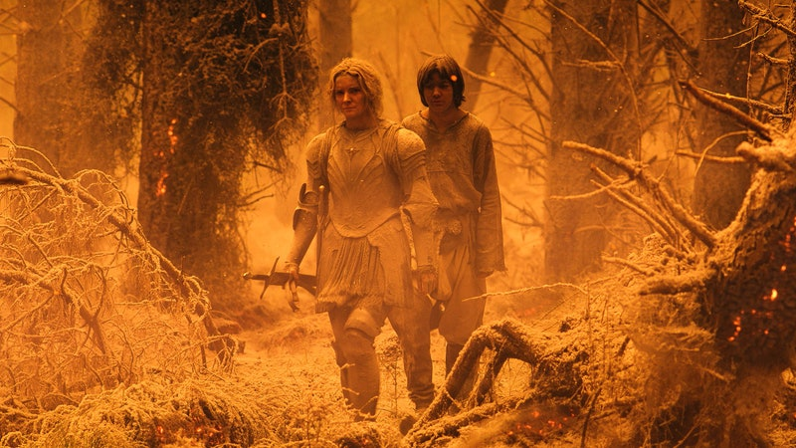

25 of the Best Amazon Prime Series Right Now

BY WIRED
- ADVERTISEMENT
As a researcher, Shaw studies how false memories arise in the brain and applies it to the criminal-justice system. Contrary to what many believe, human memories are malleable, open to suggestion and often unintentionally false. "False memories are everywhere," she says. "In everyday situations we don't really notice or care that they're happening. We call them mistakes, or say we misremember things." In the criminal-justice system, however, they can have grave consequences.
"False memories are everywhere. In everyday situations we don't really notice or care that they're happening. We call them mistakes, or say we misremember things." Julia Shaw, criminal psychologist
When Shaw works on cases she systematically looks for red flags. Cues such as age are important. For instance, before we reach the age of three, our brains cannot form memories that last into adulthood, meaning that claimed recollections from that period are suspect.
She also investigates who the accuser was with when they recalled the memory, what questions they were asked and whether in other circumstances, such as therapy, somebody could feasibly have planted the seed of a memory that took root in their minds.
Finally, Shaw looks for claims that the memory resurfaced suddenly, out of the blue, which can point to repressed memories. It's a discredited Freudian concept that supports the premise that dredging up supposedly forgotten memories can explain a person's psychological and emotional turmoil, but scientifically, it's unsubstantiated.
Understanding the ramifications of memory-gone-wrong drives Shaw. She believes that a limited awareness of memory research in therapy, policing and law is contributing to systemic failures, and is training the German police on improving interrogation methods. She wants to eradicate the misconceptions about memory. "We've done things that people in policing or law don't understand," she says. "An academic journal has ten people reading it. We're doing this to have an impact."
Allegations of sex abuse and satanic rituals hit the McMartin Preschool in Manhattan Beach, California, involving Peggy McMartin Buckey. Accusations by a mother that her child had been sodomised snowballed into an investigation, with allegations from hundreds of pupils. In 1990, these convictions were overturned as it was judged that therapists had unintentionally implanted false memories in the preschoolers' minds.

A letter written to Julia Shaw from UK housing benefit consultant John Zebedee detailing the events which caused him to murder his father in 2011, after a sexual abuse flashback. He now believes the memory to be falseSEBASTIAN NEVOLS
MOST POPULAR

India’s Government Wants Total Control of the Internet

BY VARSHA BANSAL

A Little-Known Inflammatory Disease Is Hiding in Plain Sight

BY GRACE HUCKINS

The 40 Best Films on Netflix This Week

BY WIRED

25 of the Best Amazon Prime Series Right Now

BY WIRED
  - ADVERTISEMENT
In 1989, Eileen Franklin-Lipsker, a woman living in Canoga Park, Los Angeles, was gazing at her young daughter, Jessica, when a series of disturbing memories rushed into her mind. In them, she witnessed her father, George Franklin, raping her eight-year-old friend Susan Nason in the back of his van, then crushing her skull with a rock. Nason had been missing since 1969: her body was discovered three months later in the woods outside Foster City, California, where she'd lived. But the murderer was never found. Disturbed by these memories, Franklin-Lipsker called the police. She told detectives on November 25, 1989, that 20 years earlier, her father ditched Nason's body beneath a mattress in the woods and threatened to kill her if she told anyone. She claimed that she'd repressed the shocking memory for two decades. Her recollection became the basis of an indictment against George Franklin, resulting in his trial.
In late 1990, when the trial was under way, Elizabeth Loftus, a cognitive psychologist at the University of California, Irvine, received a telephone call from Franklin's attorney, Doug Horngrad. He wanted her as an expert witness for the defence. Loftus had been studying memory for more than 20 years and had testified in several previous criminal cases. "What was puzzling to me was that [Franklin-Lipsker] kept changing her testimony," Loftus recalls. "She had maybe five or six different versions of how her memory came back." To Loftus, that signalled distorted or even fabricated memories.
In court on November 20, 1990, Loftus spent two hours explaining to the jury that memories are suggestible, and that Franklin-Lipsker's might not be as reliable as it seemed. Nevertheless, Franklin was convicted of Nason's murder later that month. "I was shocked at the conviction," Loftus says.
Five years later the courts agreed with Loftus. Franklin-Lipsker's sibling, Janice, testified that her sister had recovered the memories during hypnotherapy sessions that she had been attending to alleviate the depression she had suffered from since her teens. During those sessions, Franklin-Lipsker learned that her symptoms could indicate post-traumatic stress disorder, and was encouraged to recall the trigger. That, according to Loftus, originated the false memory. Hypnosis is considered an unreliable source by US and UK courts, so made her accounts inadmissible. Since Franklin's imprisonment rested on his daughter's eyewitness account, the judge overturned his conviction and he was freed.
MOST POPULAR

India’s Government Wants Total Control of the Internet

BY VARSHA BANSAL

A Little-Known Inflammatory Disease Is Hiding in Plain Sight

BY GRACE HUCKINS

The 40 Best Films on Netflix This Week

BY WIRED

25 of the Best Amazon Prime Series Right Now

BY WIRED
    - ADVERTISEMENT
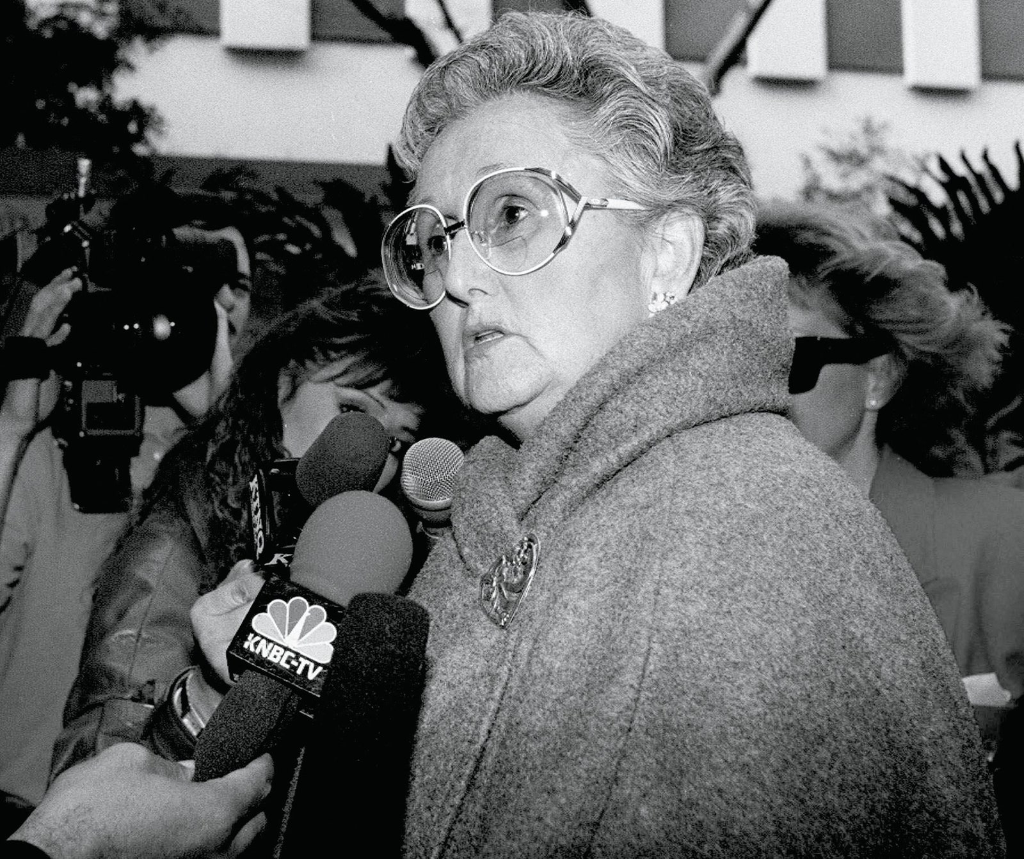
Peggy McMartin BuckeyNICK UT/AP/REX/SHUTTERSTOCK
CASE STUDY ONE
1984-1990: McMartin Preschool trial: Allegations of sex abuse and satanic rituals hit the McMartin Preschool in Manhattan Beach, California, involving Peggy McMartin Buckey. Accusations by a mother that her child had been sodomised snowballed into an investigation, with allegations from hundreds of pupils. In 1990, these convictions were overturned as it was judged that therapists had unintentionally implanted false memories in the preschoolers' minds.
Loftus's involvement in the case spurred her to pioneer research into false memory. In the 80s and 90s, she'd become intrigued by an upsurge in allegations of sexual abuse. The idea of repressed-memory theory was gaining traction at the time in alternative practices such as hypnotherapy and psychotherapy. Patients were encouraged to embrace visualising techniques, hypnotism and their imaginations to access repressed memories, which were usually pinpointed as violent sexual and physical abuse during childhood. "You began to see hundreds of people coming forward, saying that they had recovered repressed memories of massive brutalisation that they'd been completely unaware of," Loftus says. "I saw that something really big was going on here. It seemed that richly detailed whole memories were being planted into the minds of ordinary people [in therapy]."
MOST POPULAR

India’s Government Wants Total Control of the Internet

BY VARSHA BANSAL

A Little-Known Inflammatory Disease Is Hiding in Plain Sight

BY GRACE HUCKINS

The 40 Best Films on Netflix This Week

BY WIRED

25 of the Best Amazon Prime Series Right Now

BY WIRED
      - "For the time, the notion was hugely controversial", Shaw says. "It was absolutely shocking. Loftus was accused of silencing victims and was verbally attacked. I also get attacked when I speak out against repressed-memory therapies. But people like Elizabeth [Loftus] and I are concerned that this has the potential to really damage lives."
In 1995 - the year Franklin's case ended - Loftus tested out her theory experimentally. Working with graduate student Jacqueline Pickrell, she recruited 24 participants and gave each of them booklets containing details of four experiences they'd had between the ages of four and six. Researchers contacted each participant's parents for details of three true stories.
The fourth story, however, was false: it involved an imaginary incident where the subject got lost in a shopping centre as a child, was rescued by a stranger and returned to their parents. To make it believable, Loftus asked the participants' parents for details that could have been true - such as the name of a local shopping centre that actually existed when the participants were young. They were asked to think about the four memories and write down as many details as they recalled. When interviewed about their recollections, some began to share how they'd felt, and even what their rescuer was wearing - despite the fact that it was all untrue. "It was groundbreaking, because it showed that we can implant false memories of entire experiences. That's something we hadn't done before in the lab," says Shaw.
Elizabeth LoftusJODI HILTON/REX/SHUTTERSTOCK
CASE STUDY TWO
1984 - Joseph Pacely: In 1984, police arrested a man named Joseph Pacely in California because he matched the description of a suspect who'd broken into a woman's home and tried to rape her, but fled when others in the house were woken by the noise. The woman, known as Mrs M, identified Pacely from a line-up. But testifying on his behalf, cognitive psychologist and memory expert Elizabeth Loftus explained that cross-race misidentification is common (the accuser was Mexican), and that stress distorts memory. Pacely was acquitted, due to Loftus's evidence.
Ultimately, a quarter of the participants in Loftus's study developed a detailed false memory. "The key is suggestibility. Often, false memories develop because there's exposure to external suggestive information," Loftus says. "Or, people can suggest things to themselves - autosuggestion. People draw inferences about what might have happened. Those solidify and act like false memories."
MOST POPULAR

India’s Government Wants Total Control of the Internet

BY VARSHA BANSAL

A Little-Known Inflammatory Disease Is Hiding in Plain Sight

BY GRACE HUCKINS

The 40 Best Films on Netflix This Week

BY WIRED

25 of the Best Amazon Prime Series Right Now

BY WIRED
        - "A lot of people were studying memory errors at the time, but they weren't making it useful," says Shaw. "Elizabeth structured it in a way that people could take it into a courtroom."
In 1984, police arrested a man named Joseph Pacely in California because he matched the description of a suspect who'd broken into a woman's home and tried to rape her, but fled when others in the house were woken by the noise. The woman, known as Mrs M, identified Pacely from a line-up. But testifying on his behalf, cognitive psychologist and memory expert Elizabeth Loftus explained that cross-race misidentification is common (the accuser was Mexican), and that stress distorts memory. Pacely was acquitted, due to Loftus's evidence.
Julia Shaw in her London office working on a research paper about false memory issues in historical child abuse casesSEBASTIAN NEVOLS
O**ne morning in February 2016, Shaw sat cross-**legged in the swivel chair at her desk, in the department of Law and Social Sciences at London South Bank University, where she is a senior lecturer in criminology. A petite 30-year-old, Shaw talks eagerly about her work, in a flurry of words punctuated by the occasional impatient flick of her long blonde hair over a shoulder. Her interest in memory science took hold in her teens, when she began to research her family history. Half-German, half-Canadian, Shaw was born in Cologne, Germany, and spent most of her youth moving between her birthplace, the German city of Bonn, and Vancouver, Canada. "I grew up in a family where some people had difficulty monitoring reality and struggled with mental-health issues. I knew from an early age that reality could be dramatically different for people," she says. Shaw is the first in her family to finish a degree: in 2004, she started studying psychology at the Vancouver campus of Simon Fraser University (SFU). "I didn't know exactly what I was there for. I just knew that some of my family had alternate realities. I wanted to understand that."
MOST POPULAR

India’s Government Wants Total Control of the Internet

BY VARSHA BANSAL

A Little-Known Inflammatory Disease Is Hiding in Plain Sight

BY GRACE HUCKINS

The 40 Best Films on Netflix This Week

BY WIRED

25 of the Best Amazon Prime Series Right Now

BY WIRED
          - Shaw has idolised Elizabeth Loftus since her university days. "There aren't that many women at the top of our field. When I started studying psychology, she was one of the most important," she says. Her interests were influenced by Loftus's memory-implantation studies. In 2009, while moving from SFU to the University of British Columbia to conduct her PhD, Shaw became increasingly fascinated by the impact that false memories could have in criminal scenarios.
Read more: How to wipe and restore memories in rats
The idea that memory science can help with police questioning is based on evidence that's been growing since the late 80s. "Studies show that the subtle ways a question is pitched can affect what a witness reports. The feedback you give to a witness can modify how confident they are in their memories, and can shape those recollections," says Kimberly Wade, a psychologist at the University of Warwick who carries out false-memory research. Ultimately, poor interrogation methods can lead to mistaken eyewitness accounts, baseless accusations and even false confessions. "Why do people confess to things they never did? I think the most fascinating examples aren't because of torture or because they felt like they had to, but because they actually think they did it," Shaw says.
In 2015, Shaw set out to discover if she could implant detailed memories of committing a crime in people's minds, as a proxy for understanding how real-world false confessions arise. To do that, she used an updated version of Loftus's shopping-centre experiment. With her former PhD adviser Stephen Porter, a forensic psychologist at the University of British Columbia, Shaw recruited 60 student participants, splitting them into two groups. The first was told they'd experienced an event as teenagers, such as an injury, a dog attack, or losing a large sum of money. The second was told they'd committed a crime, such as assault or theft, as teenagers. To make the memories more convincing, Shaw wove in autobiographical information from the participants' parents - such as where they were living, and the name of a friend that the participant had at the age they'd supposedly committed the crime.
After the initial meeting, none of the participants could recall the false memory. But every night for three weeks, they were encouraged to spend a few minutes visualising the event. Adding some social manipulation, Shaw told them most people can recall memories, but only if they try hard enough.
"The criminal justice system has historically let down victims. Victims had terrible ordeals in those courtrooms. Nobody believed them, and they were ridiculed. Since Savile, it's gone in the opposite direction." Kevin Felstead, Director of communications at BFMS
Shaw recalls the moment she realised her experiment was working. An important cue that a false memory is taking hold is the richness of the reported detail: "I had a participant who was doing my guided imagery exercise; it seems so trivial but she said, 'Blue sky, I see a blue sky.' It showed that she was buying into the idea of actually experiencing this event and was accessing a memory, as opposed to her imagination. Those were the kinds of details that ended up being the foundation for the event itself."
The combination - a seemingly incontrovertible story backed up by real autobiographical details, visualisation and performance pressure - resulted in 70 per cent of participants generating a rich false memory of the event. Previous implantation studies had rates of 35 per cent. Unexpectedly, participants were as receptive to the false memories of committing crimes as they were to the emotional ones, Shaw says, despite the assumption that people would find it harder to believe they'd acted criminally in the past.
MOST POPULAR

India’s Government Wants Total Control of the Internet

BY VARSHA BANSAL

A Little-Known Inflammatory Disease Is Hiding in Plain Sight

BY GRACE HUCKINS

The 40 Best Films on Netflix This Week

BY WIRED

25 of the Best Amazon Prime Series Right Now

BY WIRED
            - Shaw uses the study as proof of memory's fallibility. "I always go through the study when I talk to police," she says. "They see themselves in that scenario and think 'this could be me, implanting false memories in a witness or a suspect.'"
Shaw, who is fluent in German, works mostly with German police and military forces. With the police, she typically trains senior police officers, who in turn pass on what they've learned to their subordinates at police stations across the country. In November 2016, she lectured an auditorium of 220 police officers in the Police Academy of Lower Saxony in Nienburg, Germany. As always, she started with a grounding of memory science to explain how memories fail. "It's really important to tell them not just what to do, but why. I think having that knowledge makes police much better at their jobs," Shaw says. Then she shared practical tools to help them avoid the development of false memories during criminal cases: get your witness statements early, she told them, so memories don't get muddied by time; keep people's accounts of an event separate so they don't influence each other; avoid leading questions during interrogations.
Shaw also stressed the importance of filming witness and suspect interviews, which isn't widely practiced in Germany. "It improves the outcome because police officers are more cautious about how they ask questions," she explains. It also creates an independent record so that if there are suspicions of a false memory, the police's interrogation methods can be scrutinised, she says.
Holly RamonaSHUTTERSTOCK
CASE STUDY THREE
1990 - Holly Ramona: During therapy sessions she undertook in 1990, a 19-year-old Californian girl named Holly Ramona began to recall being abused by her father. Her memories were aided by doses of sodium amytal - so-called "truth serum" - known to make people believe they're recalling real events. Her father successfully sued the therapists for negligence in 1994, and was the first case to find therapists guilty of implanting false memories.
After the lecture, Shaw received a rare confirmation that her lessons are beginning to take hold. A police officer approached her and said that, back at her station, she would now set up mandatory videotaping for witness statements.
MOST POPULAR

India’s Government Wants Total Control of the Internet

BY VARSHA BANSAL

A Little-Known Inflammatory Disease Is Hiding in Plain Sight

BY GRACE HUCKINS

The 40 Best Films on Netflix This Week

BY WIRED

25 of the Best Amazon Prime Series Right Now

BY WIRED
              - Of her work with the military, she says these ideas can be a tougher sell. "There are always one or two people, usually older men, who will just come at me with anecdotes such as 'I remember being born,' or 'I have memories of my childhood, so this proves you wrong.' I say to them, 'your anecdote doesn't really battle my science,'" Shaw teaches the German military's intelligence officers biannually: her focus is helping officers understand the flaws in their own memory so they can gather more reliable intelligence. "I teach them that you can be highly confident in things that are wrong. So you need to be careful. You're making security decisions based on information that you can't write down while you're gathering intelligence."
She's also campaigning against the military's tendency towards debriefings. In conflict situations, everyone will come back and they'll immediately debrief," Shaw says. "But a big briefing error is to all share your memories, because then they all become one. You lose all the nuances."
Recently, Shaw was informed by her trainees that the military is ditching the joint debriefing habit in favour of officers independently recording their memories right after they've been in the field. "I also found out that my book was a Christmas present for those I work with on the base," she laughs.
During therapy sessions she undertook in 1990, a 19-year-old Californian girl named Holly Ramona began to recall being abused by her father. Her memories were aided by doses of sodium amytal - so-called "truth serum" - known to make people believe they're recalling real events. Her father successfully sued the therapists for negligence in 1994, and was the first case to find therapists guilty of implanting false memories.
Edward HeathSHUTTERSTOCK
MOST POPULAR

India’s Government Wants Total Control of the Internet

BY VARSHA BANSAL

A Little-Known Inflammatory Disease Is Hiding in Plain Sight

BY GRACE HUCKINS

The 40 Best Films on Netflix This Week

BY WIRED

25 of the Best Amazon Prime Series Right Now

BY WIRED
                - What makes our memories so susceptible comes down to the way the brain stores information. That's encapsulated by a concept called Fuzzy-trace theory, first described in the 90s by American psychologists Charles Brainerd and Valerie Reyna. The theory suggests that our brains lay down memories in two forms: gist and verbatim-memory traces. Gist traces record broad features of an event; verbatim traces store precise details. "The verbatim is exact, and the gist is general," Shaw says. So, verbatim traces record a person's eye colour and name, while the gist traces register how well you got on and whether you liked them.
Memory distortions arise because the brain stores and recalls these types of information independently, according to the theory. Since gist memories are also longer-lasting and more reliable over time than verbatim, that leads to memory cross-speak. Shaw explains in her book, The Memory Illusion: "When the gist traces are strong, they can encourage what are called phantom recollective experiences, which take the familiarity of the gist as a good cue for verbatim interpretations."
CASE STUDY FOUR
2015 - Lucy X and Edward Heath: In August 2015, the UK police launched an investigation into the alleged paedophilia of deceased former UK prime minister Edward Heath (left). At the heart of this allegation was a woman, "Lucy X" who, investigating criminologist Rachel Hoskins has since discovered, underwent psychotherapy and hypnosis, which may have fuelled her allegations. In March 2017, police shut down the inquiry - which had cost more than £1 million in taxpayer's money - reportedly due to insufficient evidence.
We don't generally remember the verbatim pieces of a lot of things, according to Shaw, "so when we need to recall verbatim, it can lead to confabulation - assuming pieces that weren't originally there. We embellish our gist memories." These embellishments may come from other people's accounts, our own imaginations or what we're currently experiencing - all conniving to alter our sense of objective reality. "As a general rule, memory is a reconstructive thing," says Deryn Strange, associate professor of cognitive psychology at the John Jay College of Criminal Justice at The City University of New York. "So we are not able to play back any moment in our past and expect it to be an accurate record of what happened."
MOST POPULAR

India’s Government Wants Total Control of the Internet

BY VARSHA BANSAL

A Little-Known Inflammatory Disease Is Hiding in Plain Sight

BY GRACE HUCKINS

The 40 Best Films on Netflix This Week

BY WIRED

25 of the Best Amazon Prime Series Right Now

BY WIRED
- Read more: How emotions are 'made': why your definition of sadness is unlike anyone else's
In June 2016, Shaw crammed herself, two PhD students and four boxes into her Mini. They were returning to London from the headquarters of the British False Memory Society (BFMS) outside Birmingham. The organisation helps people who have been accused of crimes they claim they didn't commit. The boxes Shaw was transporting contained the photocopies of thousands of carefully redacted files - call transcripts, court reports and psychiatric records - which describe the approximately 2,500 false memory cases the BFMS has amassed since 1993.
Shaw and Kevin Felstead, director of communications at BFMS, are using the dataset to identify how false memories form and evolve over time. Their survey has also revealed several features that allegations have in common: usually the accuser is known to the accused; the claims principally involve alleged sexual abuse; and most accusers are undergoing questionable therapy. "People seeking therapy are vulnerable, and they're looking for answers," Shaw says. "So if the therapist says 'You must have repressed something,' they say, 'Let's go find it.'"
Across the survey, the spectre of bad therapy looms large, usually represented by hypnotherapists and psychotherapists who embrace repressed-memory techniques. "There are still psychoanalytic schools saying repression is something we need to look for. So we've got universities teaching this nonsense to people," Shaw says. The BFMS is slowly building up a therapy blacklist, so that professionals who turn up repeatedly can be identified. "I think, right now, we have a Wild West of therapeutic methods that are applied. Just like not everybody can call themselves a medical doctor, I don't think anyone should be able to say they can help with mental health," Shaw says.
Kevin Felstead from the British False Memory Society collaborated with Julia ShawSEBASTIAN NEVOLS
MOST POPULAR

India’s Government Wants Total Control of the Internet

BY VARSHA BANSAL

A Little-Known Inflammatory Disease Is Hiding in Plain Sight

BY GRACE HUCKINS

The 40 Best Films on Netflix This Week

BY WIRED

25 of the Best Amazon Prime Series Right Now

BY WIRED
  - Another facet to the problem is what Felstead calls the "post-Savile effect". In 2012, revelations of sexual abuse experienced by hundreds of people by at the hands of Jimmy Savile raised the profile of sexual-abuse victims. "The criminal justice system has historically let down victims," Felstead says. "Victims had terrible ordeals in those courtrooms. Nobody believed them, and they were ridiculed. Since Savile, it's gone in the opposite direction."
People who allege sexual abuse are frequently referred to as victims from the start. "Inquiries into historic sexual abuse also refer to people as survivors," Shaw says. In 2016, London's Metropolitan police force was criticised for adopting a policy stating that anyone who made a sexual-abuse allegation would be believed. "Referring to people as victims when you're not sure victimisation has taken place has huge potential to influence the legal process," Shaw says.
In Shaw's opinion, there's a third alternative for the criminal justice system. Besides truth and lies, there are also falsehoods masquerading as reality in people's minds. She agrees with Elizabeth Loftus's suggestions in 2008, that courts should adopt a new oath: "Do you swear to tell the truth, the whole truth, or whatever it is you think you remember?"
Emma Bryce is a science and environmental journalist. This is her first feature for WIRED. The Memory Illusionby Dr Julia Shaw is published by Random House Books, out now.
TOPICSSCIENCEPSYCHOLOGYMAGAZINEJULY 2017 ISSUE
MORE FROM WIRED UK

SCIENCE

Quantum Computing Has a Noise Problem

Today’s devices can be thrown off by the slightest environmental interference. Algorithmiq is developing ways to counteract this and harness quantum’s power.
BY AMIT KATWALA

CULTURE

The Marvel Movies From Worst to Best—and Where to Stream Them

Here’s our definitive ranking of all 30 films (and counting) in the Marvel Cinematic Universe.
BY WIRED

GEAR

Cartier Beams That Diamond Ring Right to Your Finger

The luxury brand embraces augmented reality retail with an in-store gadget that renders pieces of jewelry on your hands in 4K.
BY BOONE ASHWORTH

CULTURE

Raphael Saadiq Found the Perfect Sound for Marvel’s New Show

The legendary R&B musician rooted the music of Moon Girl and Devil Dinosaur in classic New York—just like the show itself.
BY AMOS BARSHAD

GEAR

The Rolls-Royce Spectre EV Promises Understated Luxury

WIRED got two hours behind the wheel of a preproduction prototype that might be the ultimate high-end EV. We could have gone all day.
BY JASON BARLOW

BUSINESS

ChatGPT Has Been Sucked Into India's Culture Wars

Hindu nationalists claim that the chatbot has insulted their deities, sparking an online uproar.
BY ARBAB ALI

CULTURE

The 10 Best Shows on Apple TV+ Right Now

Whether you’re enjoying a free trial or signed up purely for Ted Lasso, these are WIRED’s top picks for Apple TV+.
BY WIRED STAFF

CULTURE

What Getting CuriousTaught Jonathan Van Ness About … Everything

After seven years and 300 episodes, the podcast’s host tells WIRED about his nine favorite episodes.
BY MARAH EAKIN

WIRED is where tomorrow is realised. It is the essential source of information and ideas that make sense of a world in constant transformation. The WIRED conversation illuminates how technology is changing every aspect of our lives—from culture to business, science to design. The breakthroughs and innovations that we uncover lead to new ways of thinking, new connections, and new industries.

0
    - Privacy notice and cookie statement
    - Code of Conduct
    - Terms & conditions
    - Editorial Complaints Policy
    - Careers
    - Contact
    - MANAGE PREFERENCES
© Condé Nast Britain 2023.
https://innocenceproject.org/the-psychological-phenomena-of-wrongful-convictions/

